Final Assessment-Alternative Assessment
Semester | 202520 | Division | CIS
Assessment title in Syllabus | Final_Project_Portfolio | Program | Bachelor of Information Technology/ Bachelor of Information Systems
Course Code | CDS 2413
Course Title | INTRODUCTION TO DATA SCIENCE
Course Instructor |  | CRN
Assessment | Project Deliverable 2 – Machine Learning Model Report | Submission Date | Week 13
Student Declaration:
Academic Integrity Statement
In accordance with the HCT Academic Integrity Policy
• Students are required to refrain from all forms of academic integrity breaches as defined and explained by HCT.
• A student found guilty of having committed acts of academic integrity breach(es) will be subject to the relevant sanctions as outlined by HCT.
إفادة النزاهة الأكاديمية
وفقًا لسياسة كليات التقنية العليا للنزاهة الأكاديمية
• على الطلبة الإلتزام بلوائح وقواعد النزاهة الأكاديمية، كما هو مبيّن وموضح في السياسات والإجراءات الخاصة بكليات التقنية العليا.
• في حالة ارتكاب الطالب أي شكل من أشكال الإخلال بالنزاهة الأكاديمية، سيتعرض الى العقوبات الموضحة في السياسات ذات الصلة.
This assignment is entirely my/our own work except where I have duly acknowledged other sources in the text and listed those sources at the end of the assignment. I have not previously submitted this work to the HCT, or any other entity. I understand that I may be orally examined on my submission.

Student HCT ID(s): | H00 | H00 | H00 | H00
Student Name(s):
Student Signature
Chatbot (e.g. ChatGPT) statement
This submission allows you to use AI generated tools, but the prompt used must be stated and the response must be in red font. Include References to ChatGPT.

Instructions

Remove instructions and hints from the template before submitting the final report to BBLearn.

CLO3: Machine Learning Model (25 Points)

Preprocessing(5 Points)

Data Collection(1 Point)
The dataset was collected from a CSV file using the pandas library in Python. The function pd.read_csv() was used to load the dataset into a DataFrame for analysis. Pandas is useful because it allows easy handling and manipulation of structured data.
After loading the dataset, the independent variables (features) and dependent variable (target) were identified. The independent variables include all columns related to patient information such as age, gender, medical conditions, and lifestyle factors. The dependent variable was selected as Stroke History, which represents whether the patient had a stroke or not.
To prepare the dataset for modeling, the features (X) were separated from the target variable (y) using the drop() function. This step is important because machine learning models require clear separation between input variables and the output variable.

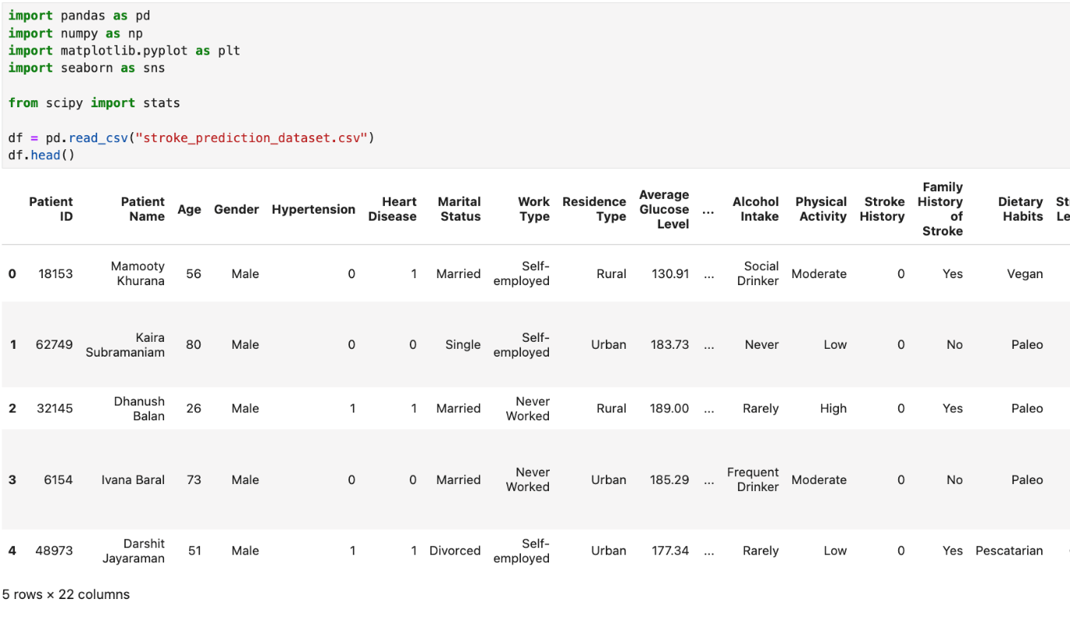

Data Cleaning (1 Point)
The dataset was cleaned to ensure high quality and reliable results. First, missing values were checked using df.isnull().sum() to identify any incomplete data. Then, missing numerical values were replaced with the mean of each column using fillna(df.mean()). This approach helps to maintain the dataset without removing useful records.
In addition, duplicate rows were removed using drop_duplicates() to avoid repeated data affecting the model performance.
These cleaning steps are important because they reduce errors, improve data consistency, and help the machine learning model learn accurate patterns from the dataset.
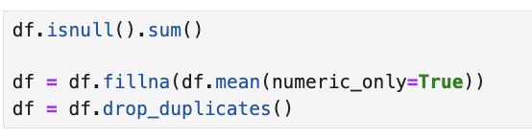

Treating the Categorical Variables (1 Point)
The dataset contains different types of categorical variables such as nominal variables (e.g., Gender, Work Type, Residence Type) and binary variables (e.g., Stroke History, Hypertension, Heart Disease).
To convert these categorical variables into numerical format, One-Hot Encoding was applied using pd.get_dummies() with drop_first=True. This technique creates new binary columns for each category and avoids redundancy by removing one category.
This method was chosen because machine learning models cannot work directly with text data. One-Hot Encoding helps to represent categorical data in a numerical form without introducing incorrect relationships between categories.

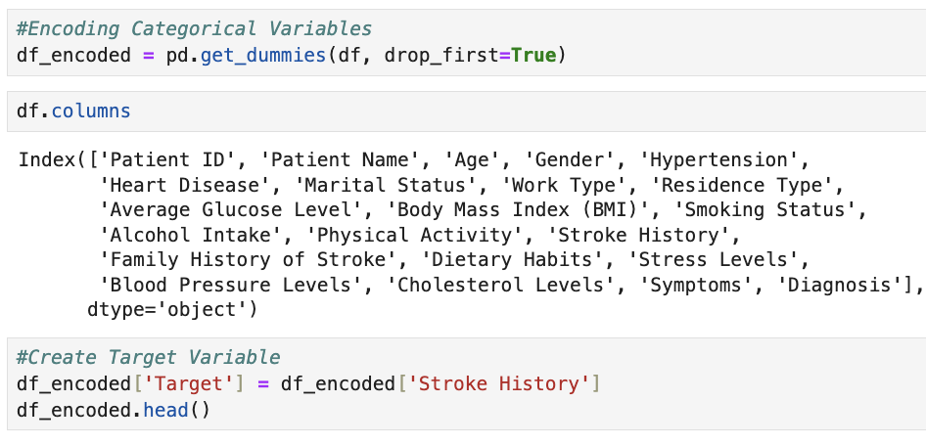

Splitting the Dataset (1 Point)

The dataset was split into training and testing sets using the train_test_split() function from sklearn. The data was divided into 80% training and 20% testing.
Splitting the dataset is important because it allows the model to learn from one portion of the data (training set) and then evaluate its performance on unseen data (testing set). This helps to check if the model generalizes well and avoids overfitting.
The 80/20 split was used because it provides enough data for training while keeping a sufficient portion for testing and evaluation.
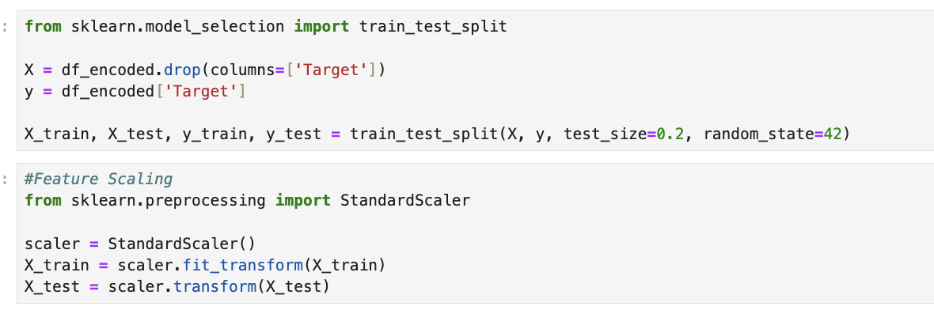

Featuring the Dataset (1 Point)

Feature scaling was applied to the dataset using the StandardScaler technique from sklearn. This method standardizes the data by transforming it to have a mean of 0 and a standard deviation of 1.
Feature scaling is important because the dataset contains variables with different ranges, such as age, glucose level, and BMI. Without scaling, some features may dominate others and affect the model performance.
StandardScaler was chosen because it is commonly used in machine learning and helps improve the accuracy and stability of models, especially for algorithms that are sensitive to feature magnitude.


Regression Model (7 Points)

Building the Regression Model (6 points)

Steps to be followed:

1. Loading and Preprocessing the Data
- Load Dataset:
The dataset was loaded using the pandas library with the read_csv() function. This allowed easy access and analysis of the data.

- Handle Missing Values:
Missing values in numerical columns were replaced using the mean of each column with fillna(). This helps keep the dataset complete without removing important data.

- Create Target Variable:
The target variable was defined as Stroke History, which represents whether a patient had a stroke. All other variables were used as independent features.



2. Detecting and Removing Outliers
- Outlier Detection:
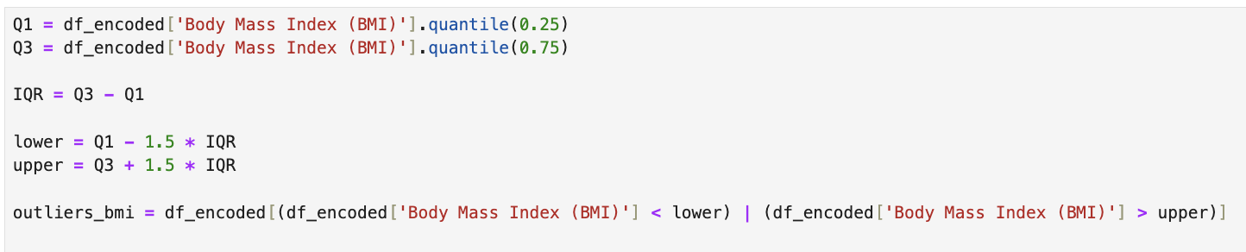
- Combine Outliers:
- Remove Outliers:
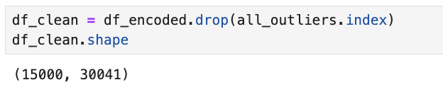
No outliers were detected in the Age variable using the IQR method. However, outlier detection was applied to other numerical features such as Average Glucose Level and BMI.

3. Splitting the Data
- Independent Variables (X):
The independent variables include Age, Average Glucose Level, BMI, and Stress Levels. These features are used as inputs to predict the target variable.
- Target Variable (y):
The target variable is Stroke History (Target), which represents whether the patient had a stroke.
- Train-Test Split:
The dataset was divided into 80% training data and 20% testing data using train_test_split(). The training set was used to train the model, while the testing set was used to evaluate its performance.
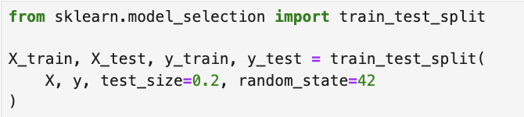
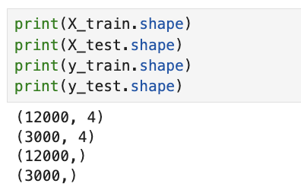
The shapes of the datasets confirm the split, with 12,000 records for training and 3,000 for testing. This split helps ensure that the model performs well on unseen data and avoids overfitting.

4. Applying Regression Models
- Regression Models:
Multiple regression models were applied to predict the target variable (Stroke History). Each model was trained using the training dataset to compare their performance.
    - Linear Regression:
This model fits a straight-line relationship between the independent variables and the target variable. It is simple and easy to interpret.
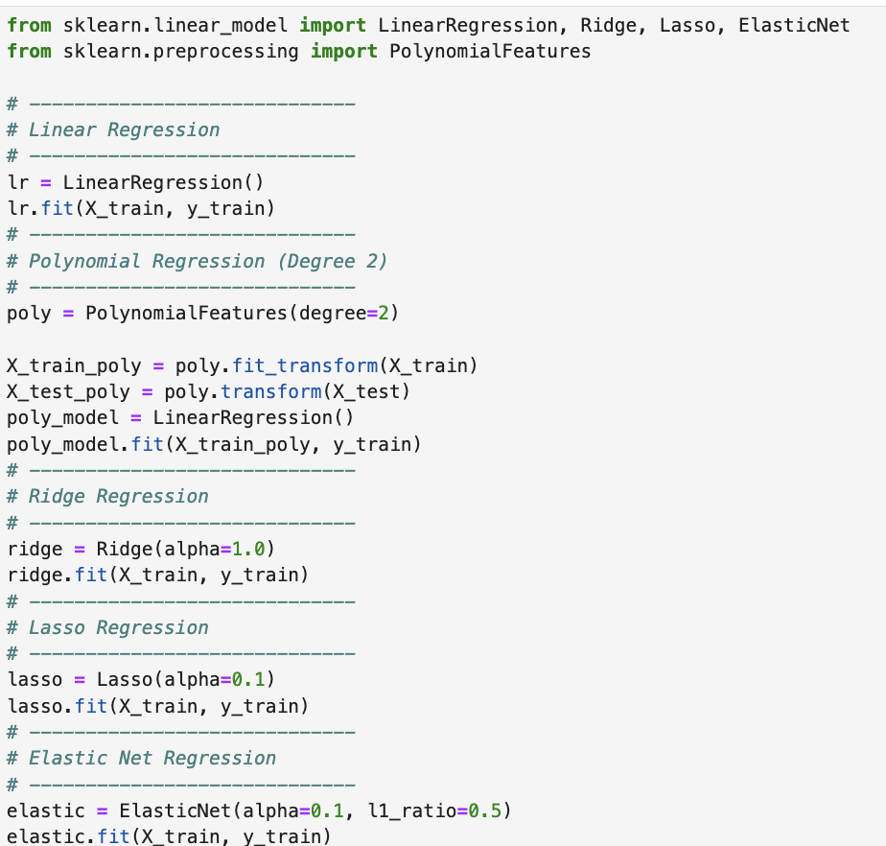
    - Polynomial Regression (Degree 2):
In this model, the features were transformed into polynomial terms of degree 2 using PolynomialFeatures. This helps capture more complex relationships between variables.

    - Ridge Regression:
Ridge regression applies L2 regularization to reduce overfitting by controlling large coefficient values. It improves model stability.

    - Lasso Regression:
Lasso regression uses L1 regularization, which helps in feature selection by reducing some coefficients to zero.

    - Elastic Net Regression:
Elastic Net combines both L1 and L2 regularization. It balances feature selection and model stability, making it more flexible.

- Polynomial Features:
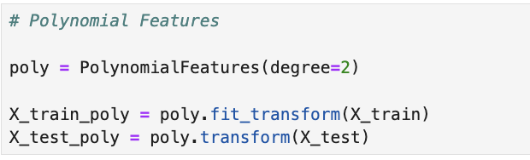

5. Evaluating Models
- Predictions:
- Each regression model was used to predict the target variable for the test dataset. The predicted values were then compared with the actual values to evaluate model performance.
- Evaluation Metrics:
  - Mean Squared Error (MSE):
- MSE measures the average squared difference between the predicted and actual values. Lower MSE indicates better model performance.
  - R-squared (R²):
- R² shows how well the model explains the variation in the target variable. A higher R² value indicates a better fit.
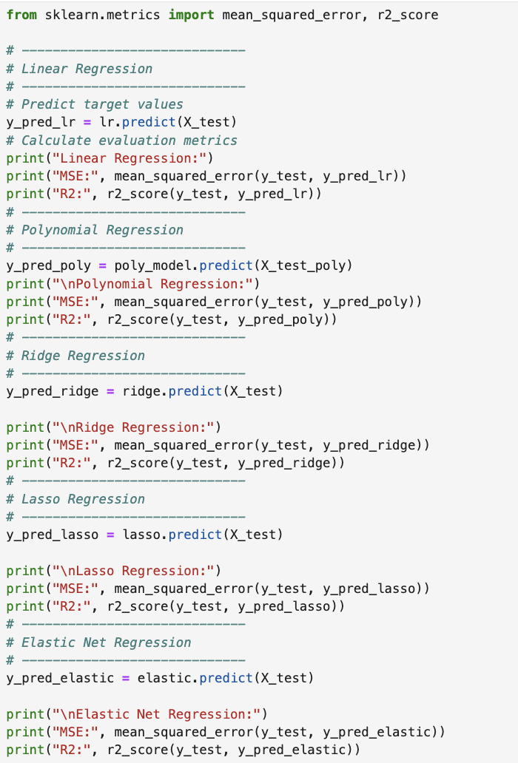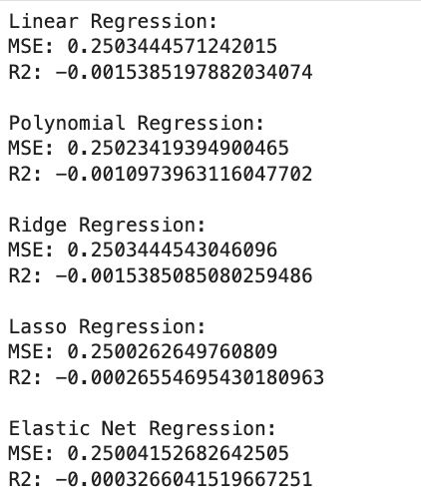
From the results, all models produced very similar MSE values, which means their prediction errors are close. However, the R² values are negative, indicating that the models are not performing well and do not explain the data effectively.
Among the models, Elastic Net Regression showed the best (least negative) R² value, making it slightly better compared to the other models.

6. Selecting the Best Model
- Comparison Table:
A comparison table was created using pandas to display all regression models along with their MSE and R² values. This table helps in clearly comparing the performance of each model.

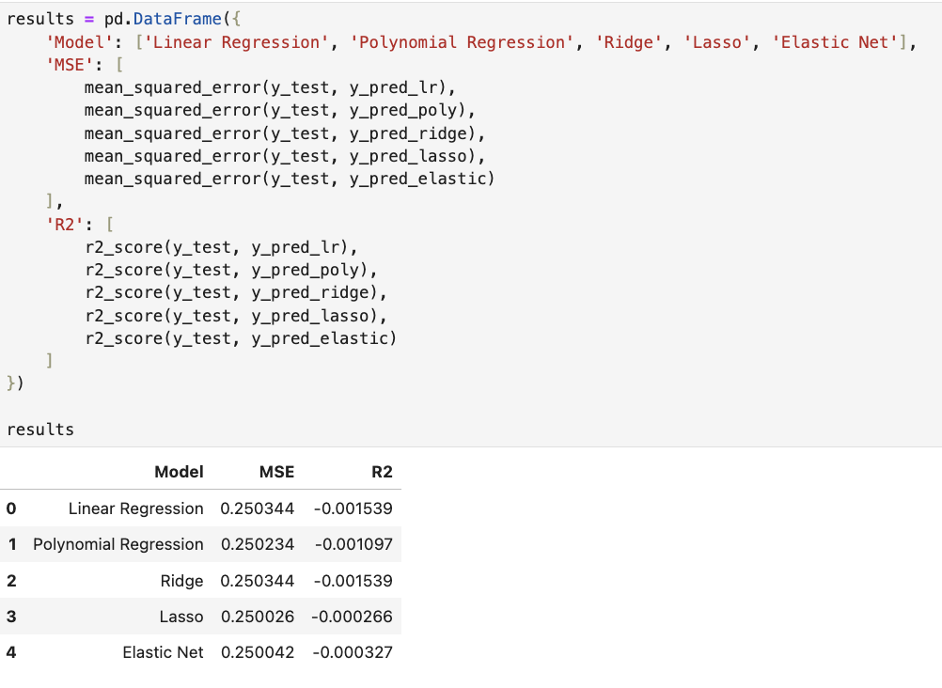
- Best-Fit Model:
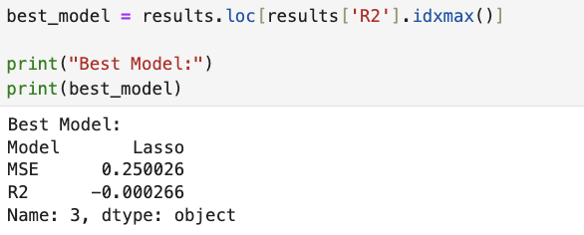
The best model was selected based on the highest R² value using idxmax(). From the results, Lasso Regression was identified as the best model because it achieved the highest (least negative) R² value and the lowest MSE compared to other models.
Although all models showed similar performance, Lasso performed slightly better, making it the most suitable model for this dataset.

7. Printing the Regression Equation
- For Polynomial Regression:
The regression equation was derived using the intercept and coefficients of the polynomial model. Polynomial features (degree 2) were included, which means the equation contains both original variables and their squared/interaction terms. This allows the model to capture more complex relationships between variables.
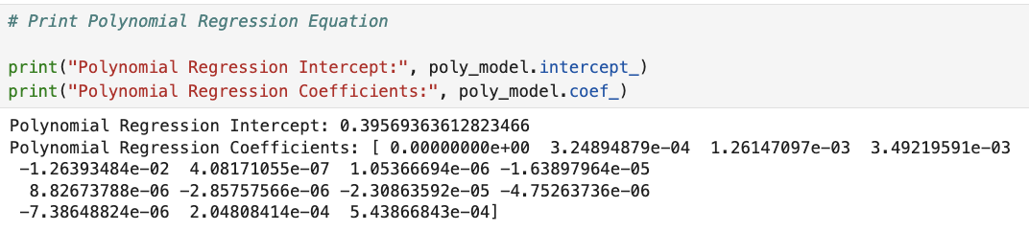
- For Other Models:
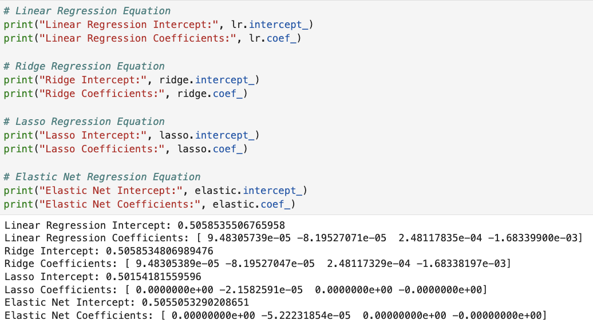
For Linear, Ridge, Lasso, and Elastic Net models, the regression equation was constructed using the intercept and coefficients of the independent variables (Age, Glucose Level, BMI, Stress Levels).
Each coefficient represents the impact of its feature on the target variable. Positive values increase the prediction, while negative values decrease it.
From the results, Lasso and Elastic Net reduced some coefficients to zero, which means they removed less important features and helped simplify the model.

8. Visualization
- Observed vs. Predicted Values:
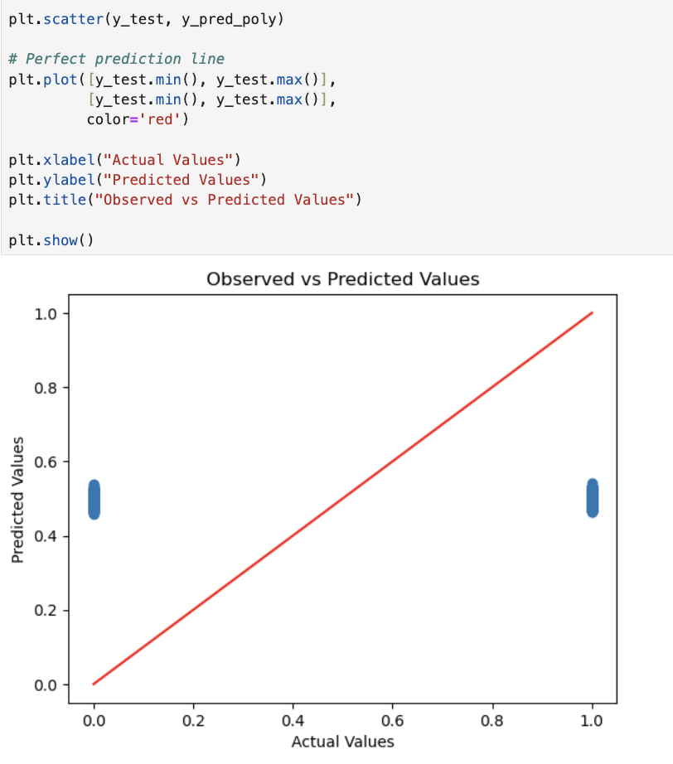
A scatter plot was created to compare the actual values with the predicted values from the model. The red diagonal line represents perfect predictions, where predicted values are equal to actual values.
From the graph, most points are far from the red line, which shows that the model predictions are not very accurate. This result supports the low R² values obtained earlier, indicating weak model performance.

Deriving the Regression Equation the Dataset (1 point)

y = intercept + (coef1 × Age) + (coef2 × Glucose) + (coef3 × BMI) + (coef4 × Stress)
y = 0.5015 + (0 × Age) + (-2.158 × 10⁻⁵ × Glucose) + (0 × BMI) + (0 × Stress)
Record 1
Age = 56, Glucose = 130.91, BMI = 25, Stress = 3
y = 0.5015 − (2.158×10⁻⁵ × 130.91)
y ≈ 0.4987
Record 2
Age = 80, Glucose = 183.73, BMI = 28, Stress = 2
y = 0.5015 − (2.158×10⁻⁵ × 183.73)
y ≈ 0.4975
Record 3
Age = 26, Glucose = 189.00, BMI = 30, Stress = 4
y = 0.5015 − (2.158×10⁻⁵ × 189.00)
y ≈ 0.4974
Record 4
Age = 73, Glucose = 185.29, BMI = 27, Stress = 3
y = 0.5015 − (2.158×10⁻⁵ × 185.29)
y ≈ 0.4975
Record 5
Age = 51, Glucose = 177.34, BMI = 29, Stress = 2
y = 0.5015 − (2.158×10⁻⁵ × 177.34)
y ≈ 0.4977

Scatter Graph:

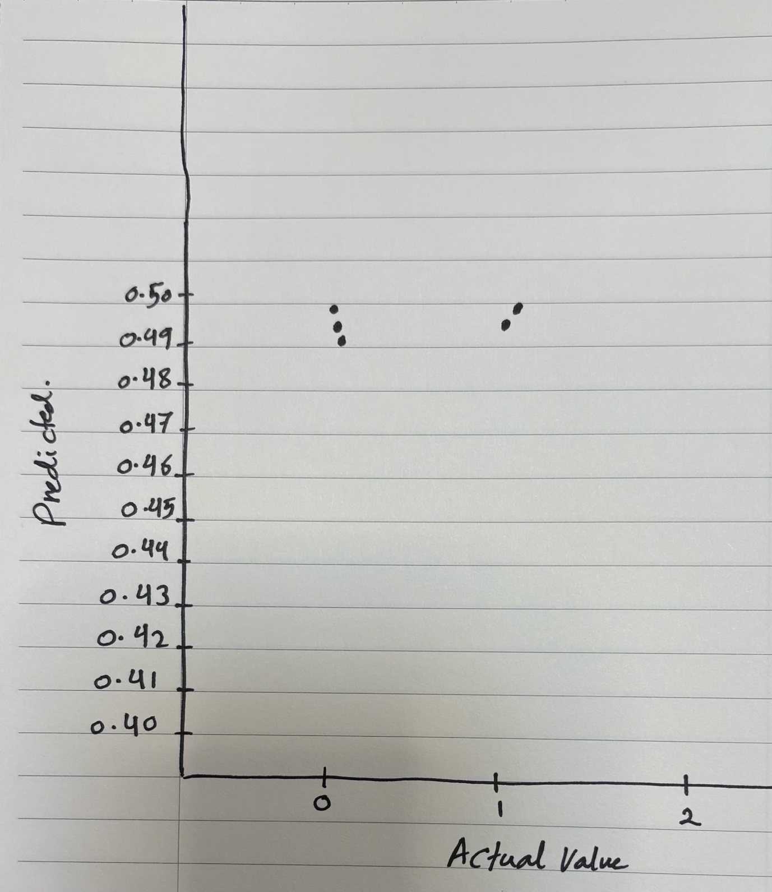

Classification Model (8 Points)

Classifying the dataset based on the target variable (1 Point)

The target variable was defined as a categorical variable based on Stroke History. A new column called Target was created, where:
0 = No Stroke
1 = Stroke
This classification allows the dataset to be used for supervised learning, where the model predicts whether a patient has a stroke or not.

Bulding classification models (6 Points)
Several classification models were implemented to predict the target variable:
Logistic Regression
K-Nearest Neighbors (KNN)
Decision Tree
Random Forest
Support Vector Machine (SVM)

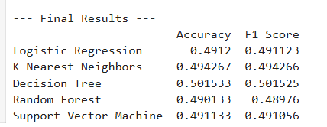
Each model was trained using the training dataset and evaluated using Accuracy and F1 Score.
From the results, the Decision Tree model achieved the highest accuracy (0.5015) and F1 score (0.5015), making it the best-performing classifier among all models.
Although the performance of all models is close, Decision Tree showed slightly better results compared to others.

No of elements on the target variable (1 Point)
The number of elements in each category of the target variable was calculated to understand the distribution of the data.
The dataset contains two classes:
Class 0 (No Stroke)
Class 1 (Stroke)
The distribution shows that both classes are present, but the model performance indicates that the dataset may not have strong patterns for classification.

Cluster Analysis (5 Points)
Building the Cluster Analysis (3 Points)

K-means clustering was performed on the stroke prediction dataset using selected health-related features: Age, Average Glucose Level, Body Mass Index (BMI), Physical Activity, and Stress Levels.
Before applying the model, the dataset was carefully preprocessed. Text-based features such as Physical Activity and Stress Levels were cleaned by standardizing their format (removing spaces and converting to lowercase). Numerical features were converted into proper numeric format, and missing or invalid values were removed to ensure data quality.
Categorical variables were transformed using one-hot encoding to make them suitable for machine learning algorithms. After preprocessing, all features were scaled using StandardScaler so that each variable contributes equally to the clustering process.
To determine the optimal number of clusters, the Elbow Method was applied by evaluating inertia values for K ranging from 1 to 10. Based on the resulting graph, K = 3 was selected as the optimal number of clusters, as the decrease in inertia becomes less significant beyond this point.
The final K-means model was trained using K = 3, and the dataset was divided into three clusters. To better understand the grouping, Principal Component Analysis (PCA) was used to reduce the data into two dimensions. The visualization shows three distinct groups, indicating that the clustering model has effectively segmented the dataset based on similarities in health and lifestyle characteristics.

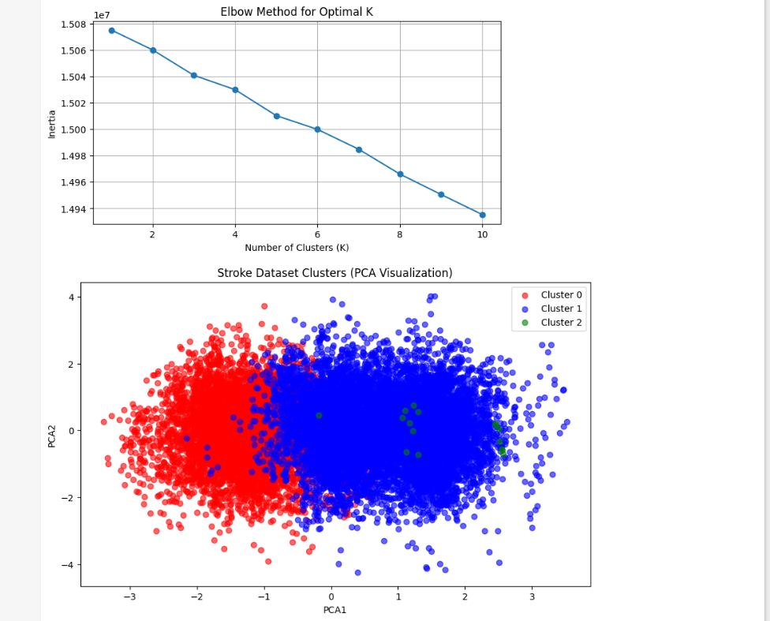

Strategy Formulation (2 Points)

Cluster 0:
This cluster represents individuals with moderate health conditions, showing average values across age, glucose levels, BMI, and lifestyle factors.
Focus on maintaining stability through preventive healthcare programs, regular screenings, and promoting balanced lifestyle habits such as moderate exercise and stress management.

Cluster 1:
This cluster includes individuals with relatively healthier profiles, such as better glucose control, healthier BMI, and more active lifestyles with lower stress levels.
This is a lower-risk group. The strategy should focus on maintaining their healthy condition through awareness campaigns, fitness programs, and personalized health tracking to prevent future health issues.
Cluster 2:
This cluster consists of individuals with higher health risks, potentially showing higher glucose levels, higher BMI, lower physical activity, or increased stress levels.
This group requires targeted intervention. Recommended actions include personalized healthcare plans, diet and exercise programs, stress reduction initiatives, and closer medical monitoring to reduce the risk of stroke.
